**PRAKTIK**

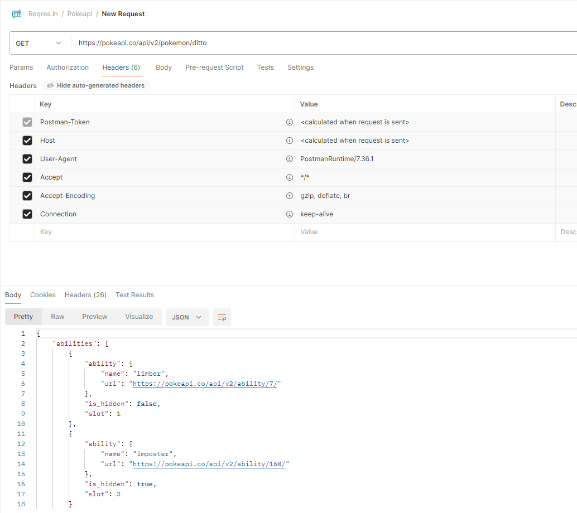

| **Input**  describe('Validate Header', () => {  it('Successfully validate content-type', () => {  cy.request('https://pokeapi.co/api/v2/pokemon/ditto').as('pokemon')  cy.get('@pokemon').its('headers').its('content-type')  .should('include', 'application/json; charset=utf-8')  });  }); |
| --- |
| **Output** |

**TUGAS**

| **Input**  describe('Validate Header', () => {  it('Successfully validate content-type', () => {  cy.request('https://pokeapi.co/api/v2/pokemon/ditto').as('pokemon')  cy.get('@pokemon').its('body').its('abilities')      });  }); |
| --- |
| **Output** |